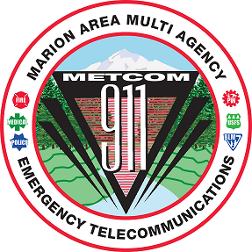
METCOM 9-1-1 GOVERNING BOARD MEETING
Date: February 12, 2025
Time: 10:00 a.m. – 11:30 a.m.
Location: Woodburn Police Department, 1060 Mt. Hood Ave, Woodburn, OR 97071
ZOOM LINK:
https://us02web.zoom.us/j/87698616269?pwd=L4JfuN2iKuYI9EEljlzyH8b2e7P4L4.1
Meeting ID: 876 9861 6269 Passcode: 08284
AGENDA

Call to Order – Mark Daniel
Board Meeting Minutes Approval
(November 19, 2024) – Mark Daniel Action Item

METCOM Director Action Item
(Mark Daniel – Appoint John Thompson Executive Director)

County Radio Project Update Update
(Mark Daniel, Colm Willis, Brian Nicholas)

Budget Committee Update
(Damian Flowers, John Thompson)

User Fee Committee Update
(Levi Eckhardt, Damian Flowers, John Thompson)

Dispatch Console Project Update
(John Thompson)

Back-up Center Phone Project Update
(John Thompson)

Staffing Update
(John Thompson)

County Radio Project Update Update
(John Thompson, Mark Daniel, Gwen Johns, Jay Alley)

Open Agenda Update

Future Meetings for Calendar Year 2025 (all start at 1000)
March 18, 2025 (Location TBD)
April 8, 2025 (Stayton Fire District)
May 28, 2025 (Location TBD)

