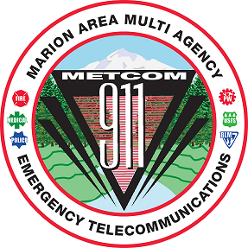
METCOM 9-1-1 GOVERNING BOARD MEETING
Date: November 19, 2024
Time: 10:00 a.m. – 11:30 a.m.
Location: Jefferson Fire District, 189 N Main St. Jefferson, OR
ZOOM LINK:
https://us02web.zoom.us/j/82476230673?pwd=gXyx88DgmbFsBCrzbkv2Z33Vcoqtkp.1
Meeting ID: 824 7623 0673 Passcode: 940698
AGENDA

Call to Order – Mark Daniel
Board Meeting Minutes Approval
(September 17, 2024) – Mark Daniel Action Item

Budget Committee Action Item

METCOM Director Discussion
(Mark Daniel)

User Fee Committee Update
(Levi Eckhardt, Damian Flowers, John Thompson)

Dispatch Console Project Update
(John Thompson)

Back-up Center Phone Project Update
(John Thompson)

Staffing Update
(John Thompson)

County Radio Project Update Update
(John Thompson, Mark Daniel, Gwen Johns, Jay Alley)

Open Agenda Update

Future Meetings for Calendar Year 2025 (all start at 1000)
- TBD

