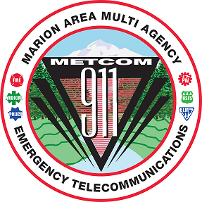
METCOM 9-1-1 GOVERNING BOARD MEETING
Date: April 7, 2025
Time: 10:00 a.m. – 11:30 a.m.
Location: Stayton Fire District 1988 W Ida St, Stayton OR
ZOOM LINK:
https://us02web.zoom.us/j/84919576229?pwd=aXlftjJtMaZ1GIzwGXInqGFo0OSacB.1
Meeting ID: 849 1957 6229 Passcode: 955549
AGENDA

Call to Order – Mark Daniel

Board Meeting Minutes Approval
(March 18, 2025) – Mark Daniel Action Item

Budget Approval Action Item
(Damian Flowers, John Thompson)

Open Agenda Update
Telecom Week April 13 -19

Future Meetings for Calendar Year 2025 (all start at 1000)
May 28, 2025 (METCOM)

