**METCOM 9-1-1**

**Governing Board Meeting Minutes**

February 12, 2025

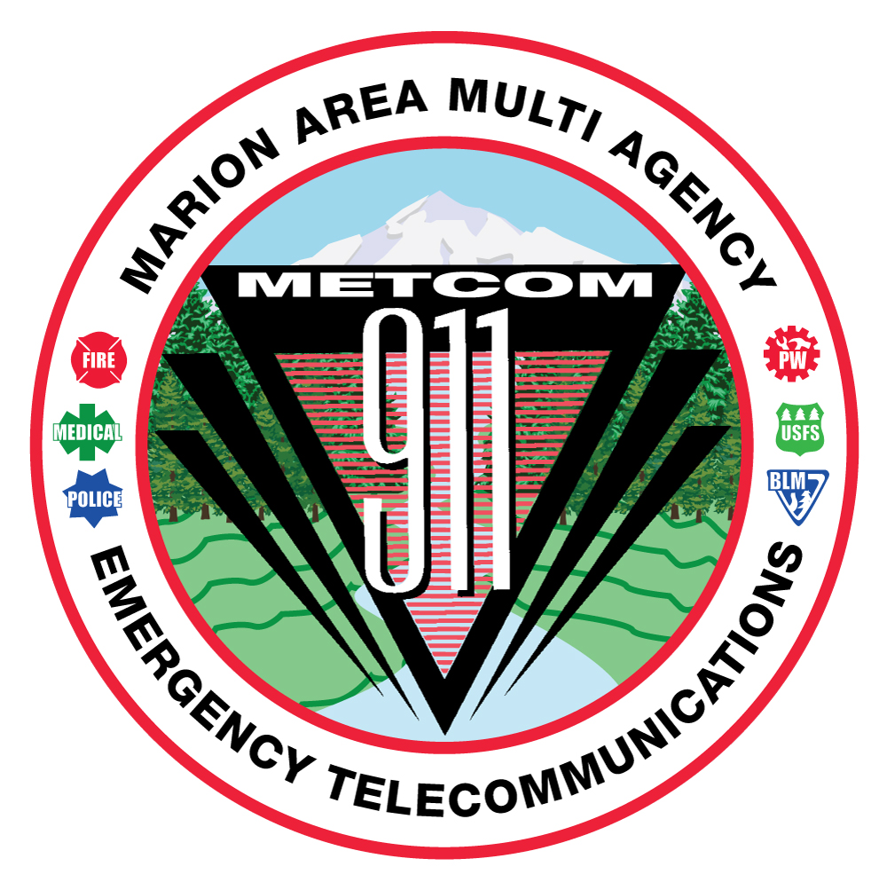

**MEMBERS IN ATTENDANDANCE:**

Jay Alley

Sherry Bensema

Mike Corless

Mark Daniel

Jordan Donat

Levi Eckhardt

Todd Engstrom

Damian Flowers

Mark Gaither

Robert Gendhar

Brandon Hamilton

Alan Hume

Gwen Johns

Bob Johnston

Michael Kahrmann

Bill Miles

Dan Mullen

Don Parise

Fred Patterson

Don Taylor

Keith Veit

Shawn Waite

**METCOM:**

Rosa Antoine

Wendy Patterson

John Thompson

**Others in Attendance:**

Danny Freitag, Santiam Ambulance

Nick Hunter, MCSO

James Montgomery, Day Wireless

Brian Nicholas, MCPW

Chris Tate, Day Wireless

Colm Willis, MC Board of Commissioners

Paul Iverson

**METCOM regular Governing Board meeting called to order at 10:02 AM by Board Chair, Mark Daniel.**

The November 19, 2024, Board meeting minutes were provided to Board members via email and available in hard copy form or by request at the meeting. Board Chair, Mark Daniel asked members asked if there were any changes to the minutes provided. None were voiced. The motion to accept the minutes were made as follows:

* Michael Kahrmann made a motion to accept the November 19th, 2024, Board Meeting minutes.
* Second by Levi Eckhardt
* Discussion: None. Motion passed, no opposition.

**METCOM Director:**

The contract negotiations for John Thompson are complete and the contact has been signed contingent upon final approval by the Board of Directors.

A motion was made by Sherry Bensema to confirm the appointment of John Thompson to the Executive Director of METCOM 911.

Motion 2nd: Dan Mullen

Discussion – None

Vote all in favor / none apposed; motion passed.

**County Radio Project Update:**

Commissioner Colm Willis, Marion County Sheriff Nick Hunter and MCPW Brian Nicholas provided information on the County Radio Project. The discussion was kicked off my Commissioner Willis apologizing to the METCOM Board on how the radio project has been communicated to them thus far. The County is currently working with several projects involving ARPA dollars. These projects must be completed by 2026 per the parameters of the ARPA funding. Currently the project estimates have been off between 30-50% of the initial estimates.

An improved radio station is important for all communities, and it is understood that there are may “lean” agencies within the county. However, the Board of Commissioners need to decide which size of system to build; a 3 or 5 channel system. It is the hope that each agency with METCOM will participate in some capacity. Agencies can participate starting at different levels with the intent the participation from METCOM user agencies will increase over time. Commissioner Willis asked METCOM agencies to answer two questions:

* How much can you afford to pay for radios each year
* Are you going to participate in the county radio system

General discussion followed:

Q: Is there a “drop dead” date that you need an answer from the agencies?

A: Commissioner Willis advised there is still a reasonable amount of time. Currently it is anticipated that the project will be signed out to 5 channels, but by only go with a 3-channel system. It was then stated that they needed to know in about 4 months’ time.

Q: What is the cost to be on the system?

A: It will depend on who is buying how many radios each year.

Q: Is there still a cost to METCOM and a charge to each agency to join, like an access fee?

A: Right now the Commissioners are concerned with the operational costs, not the capital funding gap (approximately 4 million dollars). Willis stated each agency will need to decide what the total cost they can afford.

Q: What about rising costs? Once we join, we will basically be handcuffed to the system. What assurances do, particularly the canyon agencies, have that they will be able to talk on the system? Will agencies then have to split costs between two different agency systems?

A: Commissioner Willis advised that agencies don’t need to worry about “pushing for low costs as a favor.” Marion County is also trying to keep the budget in check. Radios need to work up in the canyon area. It is currently unsafe, and I can’t have the budget costs escalate either. Brian Nicholas stated that Tate is providing a design along with coverage maps. This will include adding sites; Parrot, Mad Creek, McCully Mountain, Halls Ridge and the Crooked Finger areas. Currently there is only one coverage gap identified in the Little N. Fork Road area. Tate is currently reviewing the design and is working on a solution, with the exception of the back country.

Q: The question was again posed about the final date that a decision needs to be made by METCOM user agencies.

A: July 1, 2025.

Q: Will the subscriber fees go up if later deploy additional channels; move from a 3-channel to a 5-channel system?

A: No, independent of initial capital roll out.

Q: What about the option of looking at a privet comms vendor (i.e. Comms NW) to provide the maintenance and possibly save money.

A: Willis said the County would be willing to look into that.

Q: Currently agencies need to pay a radio subscriber fee for each seated position. For some fire departments this means that you are paying for a lot of radios that are very seldom used. Fore example, a fire station may have a cache of 80 radios, 10 of which are regularly used but an additional 70 are infrequently used but need to be maintained. This is a huge cost issue with the current subscriber fees.

A: That would be something that would need to be looked at on an operational level.

Q: What about the fee that is charged to METCOM?

A: METCOM user fees are charged to balance the revenue.

Q: Can we get a cost for only law enforcement?

A: Yes. Discussion - The subscriber fee for the radio is inclusive of the annual re-calibration of radios as this is required. It is also to maintain the radio system for the future.

Q: What is the guarantee that funds will be located to finance the shortfall/gap?

A: Fi people are willing to “be in” on the system, I am willing (Commissioner Willis) to go find the money. I am willing to not jack rates. I will sign a 5-year contract on rates.

General discussion: Users would come onto the system July 1, 2026. Agencies would not be billed prior to that date. This is for the 2026-2027 fiscal year. P25 phase 2 radios, non-proprietary system. Motorola, Tate, Harris, etc. will all work on the system.

**Budget Committee:**

Joh Thompson provided basic to the board regarding the 2025-26 FY METCOM budget. The preliminary information is as follows:

* The current anticipated increase in user fees is 3.185%
* This includes the collection of $128,000 for radio savings
* We were able to use some carryforward dollars and identify some cost reductions
* Opened for any questions or discussion – None
* The next budget committee meeting is scheduled for February 26, 2025.

**User Fee Committee:**

Levi Eckhardt reported the user fee committee has met a few times and identified the current 59/41% user fee split is equitable according to stats that were pulled and reviewed. The Fire portion will be split by using a 3-year call volume. Damian Flowers stated the law enforcement agencies were still in discussion on how to formulate the law split between agencies. Most likely a sub-committee will be formed to further discuss the law enforcement split. John Thompson advised the Board that due to the time of year and the need to move forward with the 2025-2026 FY budget, the reality is the user fee updates would be applied in the 2026-2027 budget year. Mark Daniel advised that the 190 Agreement would need to be reviewed and updated with the new user fee verbiage/formula. The consensus of the Board is to apply the new user fee formula for the 2026-2027fy budget.

**Dispatch Console Project:**

John Thompson advised METCOM dispatched from the back up facility in Stayton while the new consoles were being installed at the Woodburn location. The console project finished ahead of schedule, and everything is up and running. The METCOM staff wanted to thank all the agencies who stopped by to visit and a big thank you for the meals that were provided. It was greatly appreciated.

**Phone Project (Stayton):**

After much delay, the phone project is complete at the back up center. With the completion of the phone project, it allowed METCOM to successfully dispatch from this location during the console install project in Woodburn.

**Staffing:**

Rosa Antoine returned to METCOM as a supervisor on February 4, 2025. We have one vacant supervisor position which we will delay filling until we are further along with the dispatch staffing. We now have 12 fully trained dispatchers with an additional 4 in training and 3 open positions. We have several still in various stages of the hiring process, so staffing is looking up.

**County Radio Project - Continued:**

John will meet with Day Wireless to revisit a METCOM radio project if we don’t move forward with the County radio project.

Some roughly updated number and information:

* VHF simulcast system with two cost projections; excluding Halls Ridge being simulcast and minus Gates would be approximately $2.6 million. If we add the other two locations, it would be approximately $3 million.
* This would be for a 10-channel system
* 13 site locations
* This is a very rough budgetary number for estimates only.

Q: Can METCOM get the $950k currently held at the County back to use towards this project if we go this route?

A: Maybe. There is also an additional amount at the County from Schrader’s office. John Thompson can explore this further.

Q: Would there be grand opportunities if needed to improve our system?

A: Levi Eckhardt suggested that there maybe if we go to the State and other opportunities. John Thompson reminded the Board that MC Commissioners would also be asking the State to support their radio project.

**Open Agenda:**

Brian Nicholas –

* I am working to close the $4.7 million gap in system capitalization. It would be helpful if METCOM agencies would support the county project.
* Clarification on the user fee calculations; $75,000 identified as a fee charged to METCOM was built in almost 2 years ago with the O&M budget.
* There is not a lot of “fluff” in the numbers presented in the radio project
* The monthly subscriber fee is at the top level of annual fees. The actual annual user fees could go down $5.00 per radio.
* There are models out there to look at for “stand by” radio vs. working radios; but all that would be doing is pushing money around.
* Need supplemental revenue to the Board of Commissioners to come into the radio project.
* The Board of Commissioners is not interested in a radio system IGA. They are looking at a county provided service.
* ARPA funds can not be used for user fees, but they can be used to pre-pay radio maintenance or warranty. The current anticipated radio warranty is for 3 years.

Q: Is there any consideration to bring other users onto the system to reduce costs?

A: Yes. The 5-channel system would have capacity for that. We are looking at some city public works departments and may NW Natural.

Brian Nicholas stated he would provide some additional budget scenarios.

Chair Mark Daniel closed the meeting and adjourned at 1222.

**Future Meeting Dates:**

All meetings will start at 1000 hours.

**March 18, 2025** – Present propose 2025-26 FY Budget: Jefferson Fire Station 189 S. Main St.

**April 8, 2025** – Approve 2025-26 FY Budget: Stayton Fire Dept. 1988 W Ida St.

**May 28, 2025** – (Location TBD)