**METCOM 9-1-1**

**Governing Board Meeting Minutes**

March 18, 2025

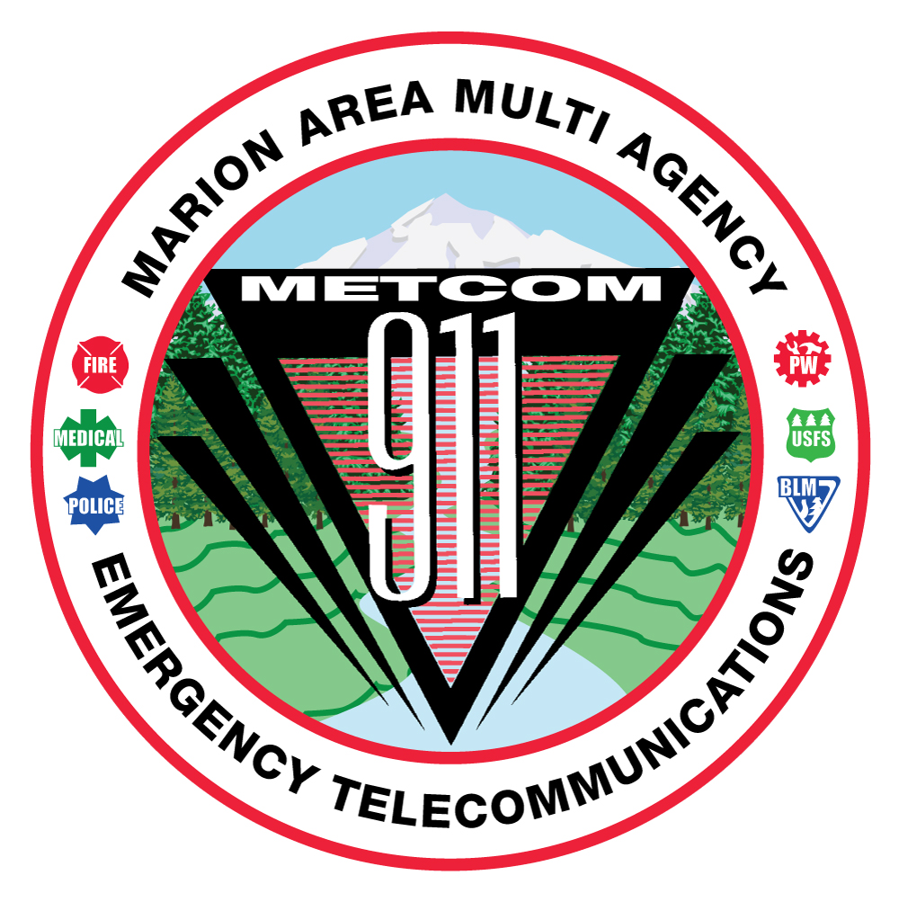

**MEMBERS IN ATTENDANDANCE:**

Jay Alley

Sherry Bensema

Mark Daniel

Jordan Donat

Levi Eckhardt

Damian Flowers

Alan Hume

Gwen Johns

Bill Miles

Jason Millican

Don Parise

Dan Mullen

Michael Kahrmann

**METCOM:**

Wendy Patterson

John Thompson

**Others in Attendance:**

Brian Nicholas, MCPW

Nick Hunter, MCSO

**METCOM regular Governing Board meeting called to order at 10:03 AM by Board Chair, Mark Daniel.**

The February 12, 2025, Board meeting minutes were provided to Board members via email and available in hard copy form or by request at the meeting. Board Chair, Mark Daniel asked members asked if there were any changes to the minutes provided. None were voiced. The motion to accept the minutes was made as follows:

* Sherry Bensema made a motion to accept the November 19th, 2024, Board Meeting minutes.
* Second by Damian Flowers
* Discussion: None. Motion passed all in favor, no opposition.

**2025-26 FY Budget Presentation:**

Chief Damian Flowers, Budget Committee chair, presented the anticipated 2025-26 FY METCOM budget to the board for information and discussion. Both the budget committee and the user fee committee have reviewed the current 59/41% user fee split and determined that the split is correct and will be maintained for the user fees. The overall presented budget reflects a 3.185% increase. The board was presented with a copy of the 2025-26 FY budget documents for review. Chief Flowers asked if there were any questions regarding the proposed budget. The following questions were presented.

* Q - Are funds for the radio project accounted for in the presented budget with the 3.185% increase?

A - Yes. The budget reflects the collection of $128,000 for radio project funds. Each agency pays their portion of the $128,00 according to the percentage of the operating budget the agency pays.

* Q - Have the contracted agencies also received the same projected increase of the 3.185%?

A – Yes. The contract agencies have received their proportionate increase according to what their contract allows, up to the 3.185%.

The proposed budget will be reviewed at the April 8th, 2025, board meeting for formal vote to approve the 2025-26 FY budget.

**County Radio Project Update:**

Brian Nicholas with Marion County Public Works (MCPW) provided information via a power point presentation. A copy of the presentation is attached to these board meeting minutes for the presentation information. Talking points and Q&A related to the presentation materials are referenced below.

* 700 will work if towers are added to the North Fork and Mad Creek sites. Also, MCSO currently uses a 2 channel VHF conventional system.
* The system is being built in concept so that agencies will have the ability to join at a later date.
* Q – If an agency currently owns a radio tower, is that taken over by Tate?

A – No. If systems currently operating on ODOT hop, you can still use that. When Tate has a full plan together, we will meet with METCOM agencies and see what they want to do regarding the towers. METCOM agencies will have access to MC hops but can still retain existing legacy hops.

* Q – Who will be responsible to fix and maintain the sites?

A – It is Tates responsibility to fix, but they can use fiber so the sites will most likely be fiber.

* Q – What happened to an 800 system? Can we talk to Salem, WACCA, etc.?

A – We wont be deploying 800 on any of the ratio sites. We will be deploying 700 but will have the ability to program radios to have the capability for inter-agency communications.

* Q – Ambulances have dual heads, will radios come with that for ambulances?

A – Patrick Hoover will research this and let us know.

Brian spoke about the initial capitalization and funding gap. This is reviewed and presented in the presentation materials.

The largest cost difference for the project is on the “Tate line.” This is largely due to the cost of subscriber units and the installation of the units.

Brian spoke of perspective funding for the funding gap. This is in the planning phase but not secured funding options.

* Marion County is hoping to secure funding through the AFG grant in the amount of $2.1 million.
* Q – Has anyone applied for the AFG grant?

A – No. Levi Eckhardt stated the most you can receive under the AFG is $1 million. In addition, it is not guaranteed that funding for the AFG grant will even be available next year to apply for.

* Q – Is there a timeline when we will know when earmarked fund are granted or not?

A – We don’t know. A timeline is not a certainty but allows for a process to follow. I don’t think it will be a year (Brian N.). When it comes to the earmark for congressional directed earmarked funds, we need to have each METCOM user sign an “ask” letter. If the funding gap is closed, “goes way,” then there may be no buy into the system, only the user fee costs.

Anticipated user fees. The formula used for the user fee calculations are:

User fee = operational costs / by the number of radios.

If all METCOM agencies participate in the project, it is anticipated the radio fee would be about $46.69 per radio per month. Using the estimated number of agencies participating today, the anticipated radio fee would be about $60.96 per radio per month.

* Q – Does the radio fee cover everything (i.e. labor, parts, etc.)?

A – Brian states there is a slide in his presentation that identifies what would be covered and what would be an additional cost.

* Q – Is there projected to be an annual increase to the fees?

A – Yes. Brian referenced the Budget Projection Spreadsheet for anticipated annual increases. He did state that subscriber fees may be rebalanced every year, based on the number of users on the system.

* Q – Will Kenwood radios work on the system?

A – Yes. Kenwood, P25 radios should work on the system. Other radio makes can work on the system as well.

Commissioner Willis’ “asks” brought forward by Brian Nicholas – If a possible 3-year potential subsidy is considered to get agencies onto the system, what would that subsidy be dollar wise?

If agencies are interested in exploring a 3-year subsidy, please respond by March 31, 2025 on what dollar amount would be needed. Email Commissioner Willis directly and copy Brian Nicholas if possible.

Fleet mapping with Tate is set to occur in April 2025. Please complete the questionnaire your agency will receive from Patrick Hoover.

**Open Agenda:**

Staffing – Loren Hall will be retiring from METCOM with his last day of work scheduled for March 27, 2025. Please feel free to stop by anytime between 0700-1900 to wish him well.

Any future CAD work will be re-directed to John Thompson.

Telecomm. Week April 13th – 19th, 2025.

Chair Mark Daniel closed the meeting and adjourned at 1222.

**Future Meeting Dates:**

All meetings will start at 1000 hours.

**April 8, 2025** – Approve 2025-26 FY Budget: Stayton Fire Dept. 1988 W Ida St.

**May 28, 2025** – Adoption of 2025-26 FY METCOM Budget: (Location TBD)